**PROJECT:INSIGHTSTREAM:**

**NAVIGATE THE NEWS LANDSCAPE**

**(NEWS APP)**

**K.SUGANYA**

**S.VAISHNAVI**

**S.SUBHASHINI**

**S.SYEDA HAJIRA PARVES**

**INTRODUCTION:**

The News Application is a dynamic web-based platform built using HTML, CSS, and JavaScript, designed to provide users with the latest updates across various categories. This project was developed in Visual Studio Code, with the main focus on ensuring a user-friendly interface, seamless navigation, and a responsive design that works well across different devices.

The application features a wide range of news categories, including business, sports, technology, and politics. By categorizing the news content, it enables users to easily navigate through their preferred sections and stay updated on the topics that interest them the most. The "Business" section offers insights into the latest market trends, corporate news, and economic developments. The "Sports" section provides updates on national and international sporting events, scores, and highlights. The "Technology" section focuses on advancements in tech, gadgets, and innovations, while the "Politics" section keeps users informed about governmental policies, political news, and elections.

**SYSTEM ANALYSIS:**

**This Section describes the Software and Hardware requirements of the system.**

**Software requirements:**

Operating system : Windows 10

Editor : Visual Studio Code

Languages : HTML , CSS, JAVASCRIPT

**Hardware requirements:**

Processor : Intel(R)

Processor Type : Core(TM) i5-6200U

Processor Speed : 2.4 GHz

RAM Size : 8 GB

Hard Drive Size : 1 TB

**SOFTWARE TOOLS:**

The whole project has been divided into two parts the front end and back end.

**HTML: Hyper Text Markup Language**

HTML is the standard markup language for documents designed to be displayed in a web browser. It can be assisted by technologies such as Cascading Style Sheets (CSS) and scripting languages such as JavaScript.

Web browsers receive HTML documents from a web server or from local storage and render the documents into multimedia web pages. HTML describes the structure of a web page semantically and originally included cues for the appearance of the document.

HTML elements are the building blocks of HTML pages. With HTML constructs, images and other objects such as interactive forms may be embedded into the rendered page.HTML provides a means to create structured documents by denoting structural semantics for text such as headings, paragraphs, lists, links, quotes and other items.

HTML elements are delineated by tags, written using angle brackets. Tags such as <img /> and <input /> directly introduce content into the page. Other tags such as <p> surround and provide information about document text and may include other tags as sub-elements. Browsers do not display the HTML tags but use them to interpret the content of the page.

HTML can embed programs written in a scripting language such as JavaScript, which affects the behavior and content of web pages. Inclusion of CSS defines the look and layout of content. The World Wide Web Consortium (W3C), former maintainer of the HTML and current maintainer of the CSS standards, has encouraged the use of CSS over explicit presentational HTML since 1997.[2] A form of HTML, known as HTML5, is used to display video and audio, primarily using the <canvas> element, in collaboration with javascript.

**CSS: Cascading Style Sheets**

CSS was first proposed by Håkon Wium Lie on 10 October 1994.At the time, Lie was working with Tim Berners-Lee at CERN. Several other style sheet languages for the web were proposed around the same time, and discussions on public mailing lists and inside World Wide Web Consortium resulted in the first W3C CSS Recommendation (CSS1) being released in 1996. In particular, a proposal by Bert Bos was influential; he became co-author of CSS1, and is regarded as co-creator of CSS.

CSS is designed to enable the separation of content and presentation, including layout, colors, and fonts. This separation can improve content accessibility; provide more flexibility and control in the specification of presentation characteristics; enable multiple web pages to share formatting by specifying the relevant CSS in a separate. css file, which reduces complexity and repetition in the structural content; and enable the file to be cached to improve the page load speed between the pages that share the file and its formatting.

Separation of formatting and content also makes it feasible to present the same page in different styles for different rendering methods, such as on-screen, in print, by voice (via speech-based browser or screen reader), and on Braille-based tactile devices. CSS also has rules for alternate formatting if the content is accessed on a mobile device. The name cascading comes from the specified priority to determine which style rule applies if more than one rule matches a particular element. This cascading priority scheme is predictable. The CSS specifications are maintained by the World Wide Web Consortium (W3C). Internet media type (MIME type) text/css is registered for use with CSS by RFC 2318 (March 1998). The W3C operates a free CSS validation service for CSS documents.

In addition to HTML, other markup languages support the use of CSS including XHTML, plain XML, SVG, and XUL.

**Javascript** : *Is the most popular programming language* in the world.

That makes it a programmer‘s great choice. Once you learnt Javascript, it helps you developing great front-end as well as back-end softwares using different Javascript based frameworks like jQuery, Node.JS etc. is everywhere, it comes installed on every modern web browser and so to learn Javascript you really do not need any special environment setup. For example Chrome, Mozilla Firefox , Safari and every browser you know as of today, supports Javascript, They Javascript helps you create really beautiful and crazy fast websites. You can develop your website with a console like look and feel and give your users the best Graphical User Experience. JavaScript usage has now extended to mobile app development, desktop app development, and game development. This opens many opportunities for you as Javascript Programmer.

Due to high demand, there is tons of job growth and high pay for those who know JavaScript. You can navigate over to different job sites to see what having JavaScript skills looks like in the job market.

JavaScript (JS) is a lightweight, interpreted, or just-in-time compiled programming language with first-class functions. While it is most well-known as the scripting language for Web pages, many non-browser environments also use it, such as Node.js, Apache CouchDB and Adobe Acrobat. JavaScript is a prototype-based, multi-paradigm, single-threaded, dynamic language, supporting object-oriented, imperative, and declarative (e.g. functional programming) styles.

Read more about JavaScript. This section is dedicated to the JavaScript language itself, and not the parts that are specific to Web pages or other host environments. For information about APIs that are specific to Web

**HTML SOURCE CODE: index.html**

<!DOCTYPE html>

<html lang="en">

<head>

<meta charset="utf-8" />

<link rel="icon" href="%PUBLIC_URL%/favicon.ico" />

<meta name="viewport" content="width=device-width, initial-scale=1" />

<meta name="theme-color" content="#000000" />

<meta

name="description"

content="Web site created using create-react-app"

/>

<link rel="apple-touch-icon" href="%PUBLIC_URL%/logo192.png" />

<!--

manifest.json provides metadata used when your web app is installed on a

user's mobile device or desktop. See https://developers.google.com/web/fundamentals/web-app-manifest/

-->

<link rel="manifest" href="%PUBLIC_URL%/manifest.json" />

<!--

Notice the use of %PUBLIC_URL% in the tags above.

It will be replaced with the URL of the `public` folder during the build.

Only files inside the `public` folder can be referenced from the HTML.

Unlike "/favicon.ico" or "favicon.ico", "%PUBLIC_URL%/favicon.ico" will

work correctly both with client-side routing and a non-root public URL.

Learn how to configure a non-root public URL by running `npm run build`.

-->

<title>React App</title>

</head>

<body>

<noscript>You need to enable JavaScript to run this app.</noscript>

<div id="root"></div>

<!--

This HTML file is a template.

If you open it directly in the browser, you will see an empty page.

You can add webfonts, meta tags, or analytics to this file.

The build step will place the bundled scripts into the <body> tag.

To begin the development, run `npm start` or `yarn start`.

To create a production bundle, use `npm run build` or `yarn build`.

-->

</body>

</html>

**CSS CODE: App.css**

.App {

text-align: center;

}

.App-logo {

height: 40vmin;

pointer-events: none;

}

@media (prefers-reduced-motion: no-preference) {

.App-logo {

animation: App-logo-spin infinite 20s linear;

}

}

.App-header {

background-color: #282c34;

min-height: 100vh;

display: flex;

flex-direction: column;

align-items: center;

justify-content: center;

font-size: calc(10px + 2vmin);

color: white;

}

.App-link {

color: #61dafb;

}

@keyframes App-logo-spin {

from {

transform: rotate(0deg);

}

to {

transform: rotate(360deg);

}

}

**Index.css**

body {

margin: 0;

font-family: -apple-system, BlinkMacSystemFont, 'Segoe UI', 'Roboto', 'Oxygen',

'Ubuntu', 'Cantarell', 'Fira Sans', 'Droid Sans', 'Helvetica Neue',

sans-serif;

-webkit-font-smoothing: antialiased;

-moz-osx-font-smoothing: grayscale;

}

code {

font-family: source-code-pro, Menlo, Monaco, Consolas, 'Courier New',

monospace;

}

**JAVASCRIPT CODE:App.js**

import logo from './logo.svg';

import './App.css';

function App() {

return (

<div className="App">

<header className="App-header">

<img src={logo} className="App-logo" alt="logo" />

<p>

Edit <code>src/App.js</code> and save to reload.

</p>

<a

className="App-link"

href="https://reactjs.org"

target="_blank"

rel="noopener noreferrer"

>

Learn React

</a>

</header>

</div>

);

}

export default App;

**App.test.js**

import { render, screen } from '@testing-library/react';

import App from './App';

test('renders learn react link', () => {

render(<App />);

const linkElement = screen.getByText(/learn react/i);

expect(linkElement).toBeInTheDocument();

});

**Index.js**

import React from 'react';

import ReactDOM from 'react-dom/client';

import './index.css';

import App from './App';

import reportWebVitals from './reportWebVitals';

const root = ReactDOM.createRoot(document.getElementById('root'));

root.render(

<React.StrictMode>

<App />

</React.StrictMode>

);

// If you want to start measuring performance in your app, pass a function

// to log results (for example: reportWebVitals(console.log))

// or send to an analytics endpoint. Learn more: https://bit.ly/CRA-vitals

reportWebVitals();

**setupTests.js**

// jest-dom adds custom jest matchers for asserting on DOM nodes.

// allows you to do things like:

// expect(element).toHaveTextContent(/react/i)

// learn more: https://github.com/testing-library/jest-dom

import '@testing-library/jest-dom';

**JSON CODE:package.json**

{

"name": "my-news-app",

"version": "0.1.0",

"private": true,

"dependencies": {

"@testing-library/dom": "^10.4.0",

"@testing-library/jest-dom": "^6.6.3",

"@testing-library/react": "^16.2.0",

"@testing-library/user-event": "^13.5.0",

"react": "^19.0.0",

"react-dom": "^19.0.0",

"react-scripts": "5.0.1",

"web-vitals": "^2.1.4"

},

"scripts": {

"start": "react-scripts start",

"build": "react-scripts build",

"test": "react-scripts test",

"eject": "react-scripts eject"

},

"eslintConfig": {

"extends": [

"react-app",

"react-app/jest"

]

},

"browserslist": {

"production": [

">0.2%",

"not dead",

"not op_mini all"

],

"development": [

"last 1 chrome version",

"last 1 firefox version",

"last 1 safari version"

]

}

}

**manifest.json**

{

"short_name": "React App",

"name": "Create React App Sample",

"icons": [

{

"src": "favicon.ico",

"sizes": "64x64 32x32 24x24 16x16",

"type": "image/x-icon"

},

{

"src": "logo192.png",

"type": "image/png",

"sizes": "192x192"

},

{

"src": "logo512.png",

"type": "image/png",

"sizes": "512x512"

}

],

"start_url": ".",

"display": "standalone",

"theme_color": "#000000",

"background_color": "#ffffff"

}

**PROCEDURE:**

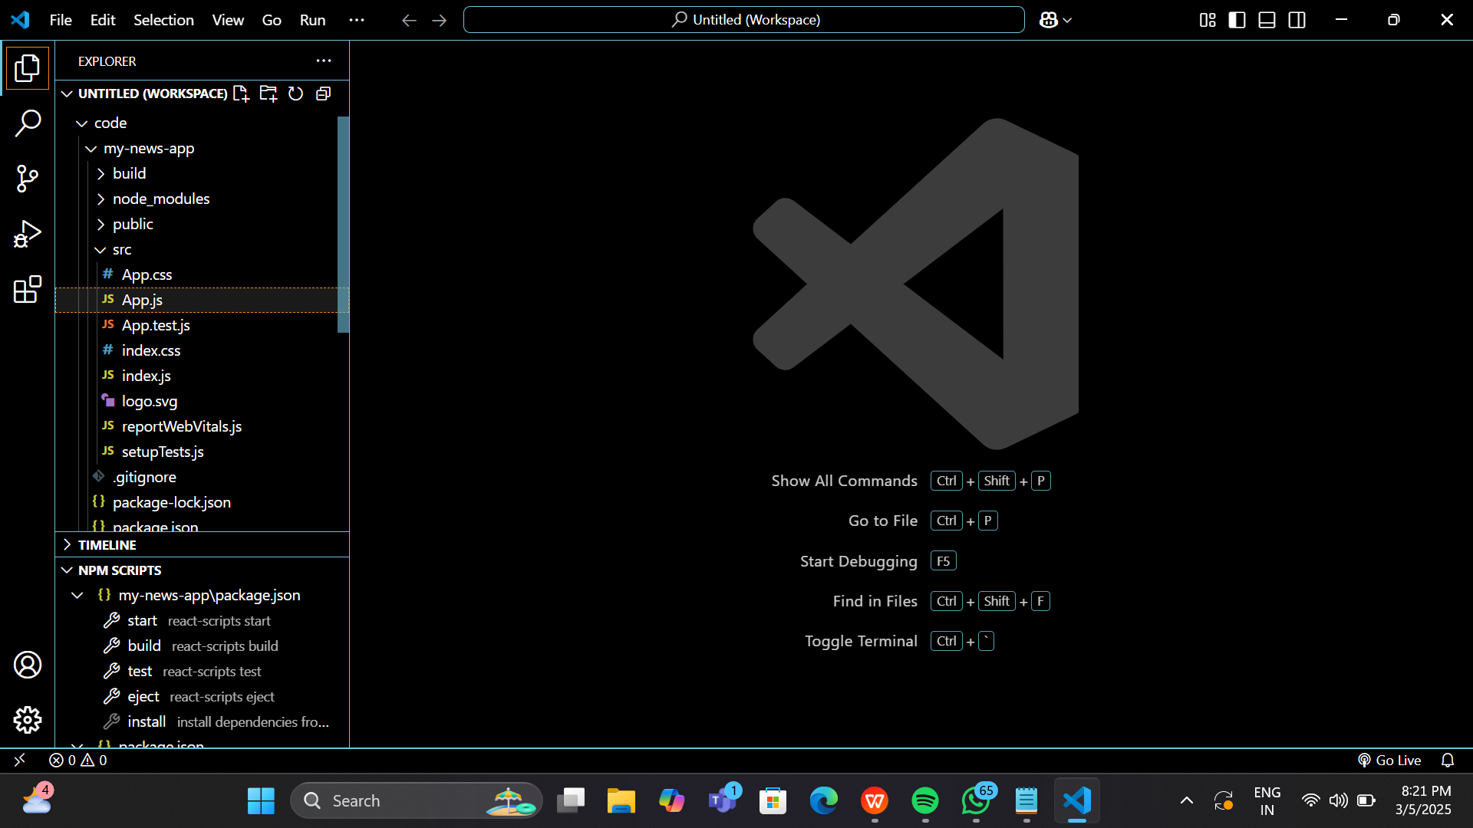

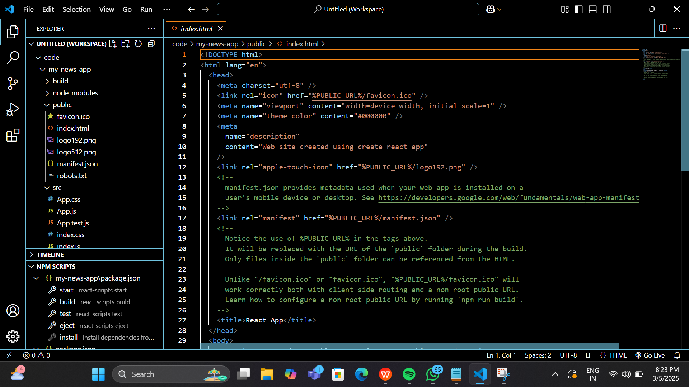

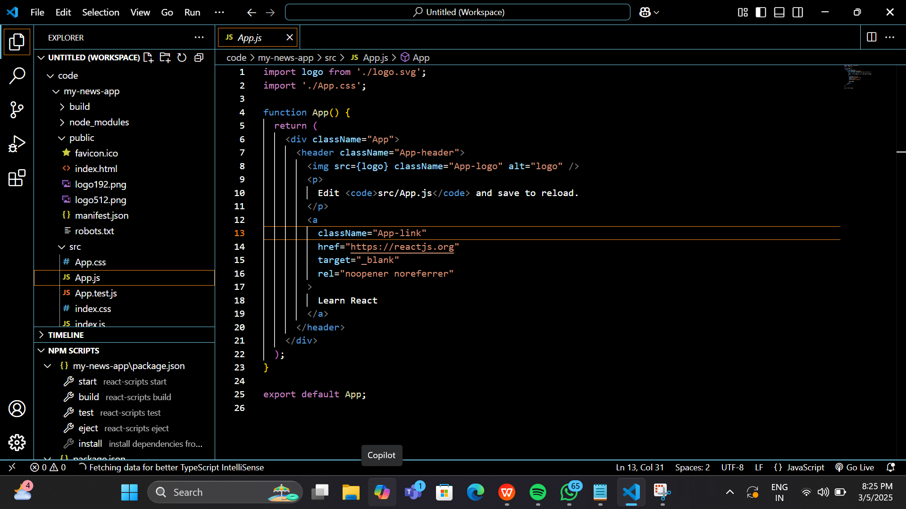

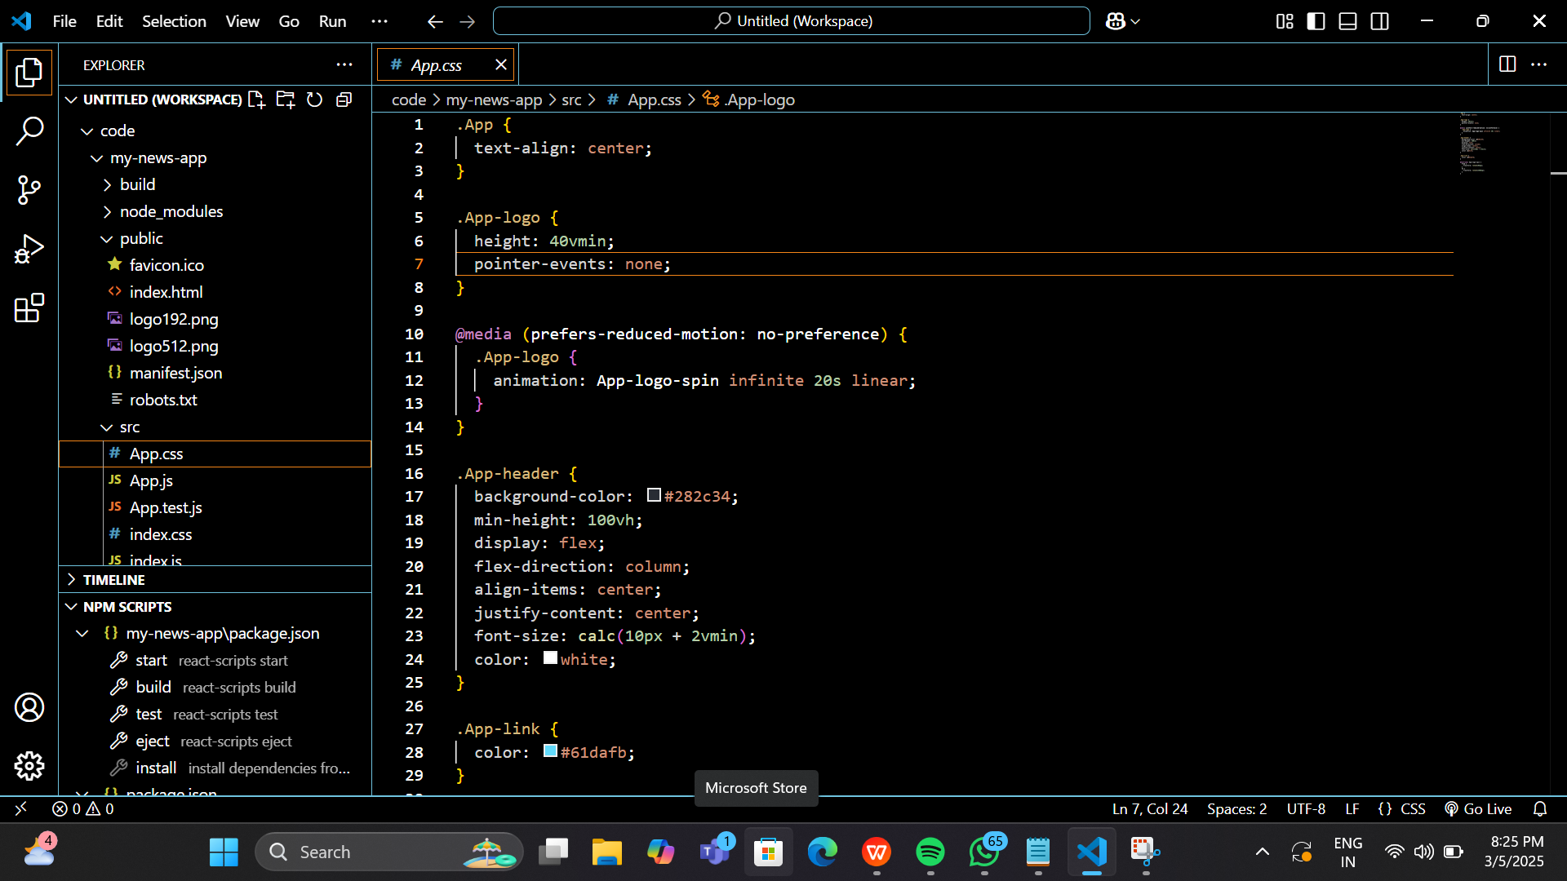

**OUTPUT:**

0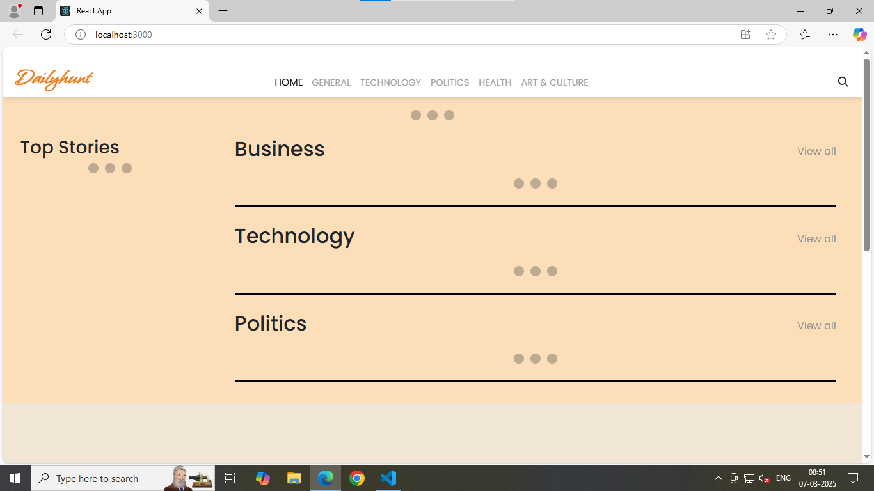

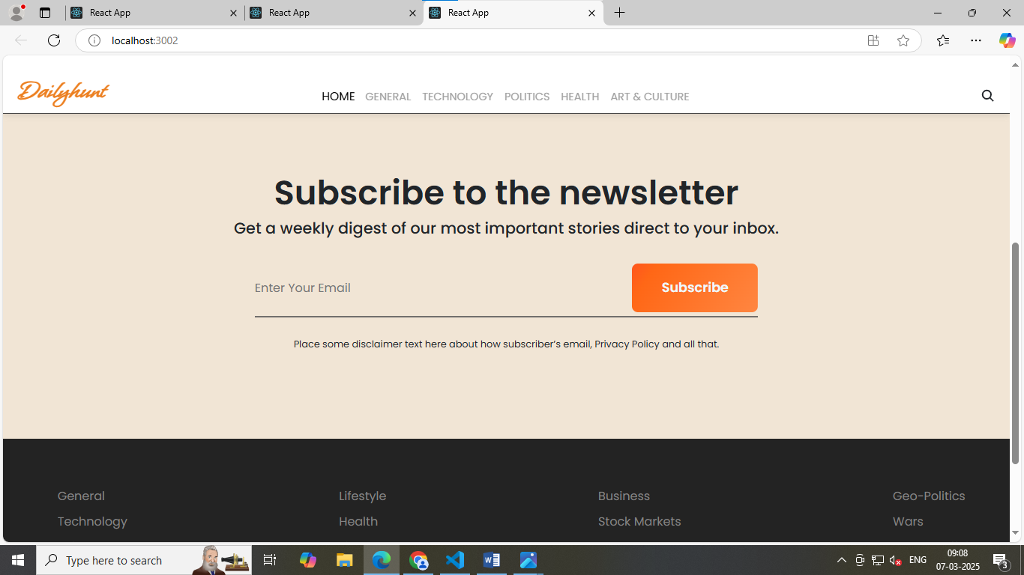

**CONCLUSION:**

the News Application is an efficient and organized platform that caters to users' diverse news interests by providing categorized content in business, sports, technology, and politics. Developed using HTML, CSS, and JavaScript in Visual Studio Code, the application ensures a seamless, responsive, and user-friendly experience across different devices. The intuitive interface and search functionality make it easy for users to quickly find relevant news and stay informed.

By delivering real-time updates from reliable sources, the application ensures that users have access to accurate and credible information. The clean design and dynamic content loading add to the overall smooth experience, keeping users engaged. This project showcases the potential of web development technologies in creating practical, informative applications that meet users' needs for timely information. The News Application is a valuable tool for anyone seeking to stay updated with current events in an accessible and well-structured format.